**Name: Varad Patil**

**Batch: A2**

**Roll no: 120A2036**

**EXPERIMENT NO. 3**

**TO DETERMINE THE REGION OF SINGLE MODE OPERATION OF AN OPTICAL FIBER**

**EXPERIMENT NO. 3**

**TO DETERMINE THE REGION OF SINGLE MODE OPERATION OF AN OPTICAL FIBER**

**OBJECTIVE:**

The objective of this experiment is to determine the region of single mode operation of an optical fiber with core diameter of 7.2 μm, core and cladding refractive indices of 1.447 and 1.442 respectively.

**SOFTWARE USED: Python**

**THEORY:**

Only the fundamental zero-order mode is transmitted in a single-mode fiber. The light beam travels straight through the fiber with no reflections from the core-cladding sidewalls at all. Single-mode fiber is characterized by the wavelength cutoff value, which is dependent on core diameter, NA and wavelength of operation. Below the cutoff wavelength, higher-order modes may also propagate, which changes the fiber’s characteristics.

The actual number of modes that can be propagated through a fiber depends on the core diameter, the numerical aperture and the wavelength of the light being transmitted. These may be combined into the normalized frequency parameter or *V* number,



where a is the core radius, λ is the wavelength, and n is the index of the core and the cladding. The condition for single-mode operation is that:



Perhaps more important and useful is the cutoff wavelength. This is the wavelength below which the fiber will allow propagation of multiple modes and can be expressed as:



A fiber is typically chosen with a cutoff wavelength slightly below the desired operating wavelength. For lasers typically used as sources (with output wavelengths between 850 and 1550 nm), the core diameter of a single-mode fiber is in the range of 3 to 10 µm.

**Code:**

import math

import matplotlib.pyplot as plt

import numpy as np

d = 8

n1 = 1.447

n2 = 1.442

NA = math.sqrt(n1**2 - n2**2)

cut_lambda = math.pi*d*NA / 2.405

L = np.arange(0.8, 1.6, 0.01)

v = []

for i in L:

  v.append(math.pi*d*NA / i)

plt.plot(L, v)

plt.title("Single Mode Operation Plot")

plt.xlabel("wavelength")

plt.ylabel("V-number")

plt.axhspan(min(v), 2.405, facecolor ='g', alpha = 0.2)

plt.axvspan(cut_lambda, 1.6, facecolor ='b', alpha = 0.2)

plt.text(1.3, 2.1, 'single mode operation')

plt.show()

**Output:**

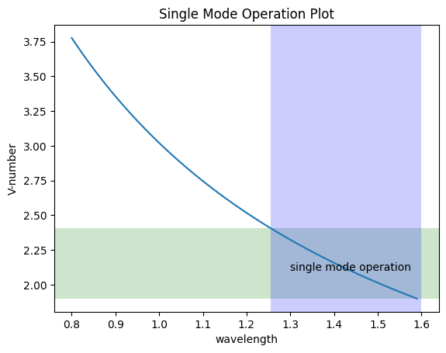

**CONCLUSION:**

**From the above experiment, we can say that for value of λ greater than or equal to λc Single mode Operation propagates and if λ is less than λc Higher modes propagates.**